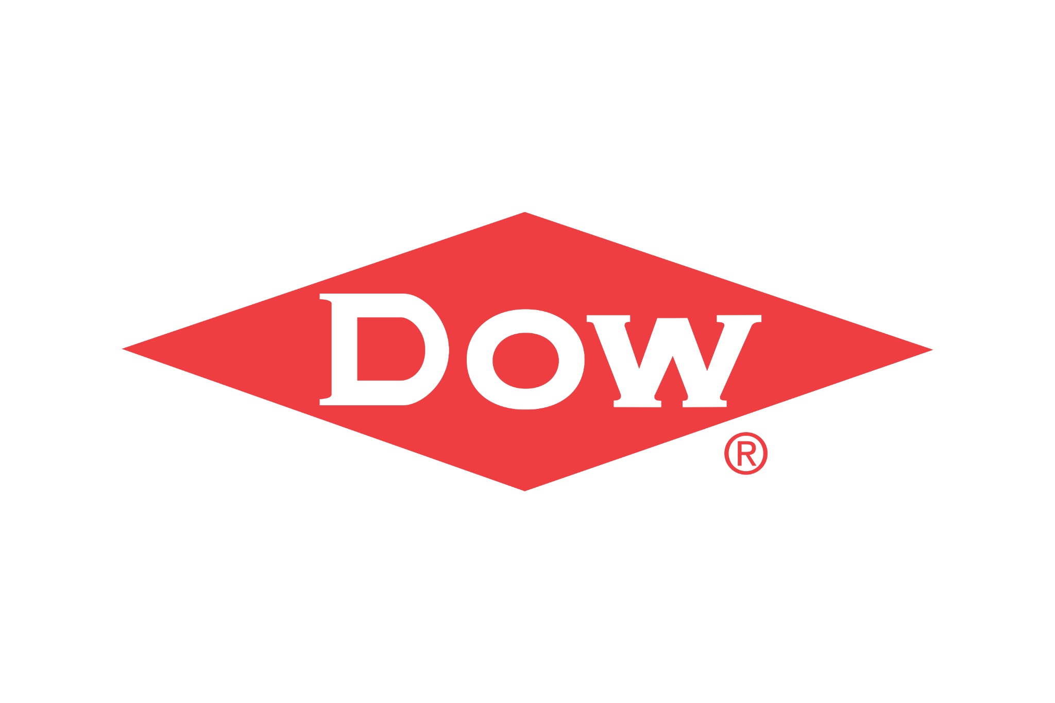

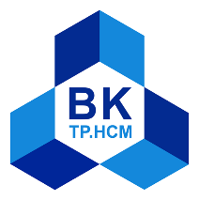

VIETNAM NATIONAL UNIVERSITY HO CHI MINH CITY
HO CHI MINH CITY UNIVERSITY OF TECHNOLOGY
HCMC, / / 2026
GRAND FINAL REGISTRATION FORM
BACH KHOA INNOVATION 2026
Dow Chemical Challenge (U-I)
Topic
“DESIGN FOR CIRCULARITY CHALLENGE (D4C)”

TEAM'S NAME: ____________________________________________

COMPETITION FORMAT — GRAND FINAL
07:15 – 08:30 In-booth (3-min introduction, 4-min Q&A) — Top 10 teams. This is a competitive round: the top 5 teams advance to On-stage.
08:45 – 10:00 On-stage (4-min presentation, 6-min Q&A) — Only the top 5 teams selected from the In-booth round.
Note: The In-booth round is where you introduce your prototype to the judges — having a prototype ready to show is an advantage.

1. TEAM LEADER
Full name: Huỳnh Khánh Tường
ID Number (if any): 2554055
Email (HCMUT/personal email): tuong.huynhnakitomo@hcmut.edu.vn
Phone number: 0363878061
2. MENTOR (IF ANY)
Full name: Lương Thanh Nhật
Title: Executive Committee Member, Faculty of Mechanical Engineering Trade Union
Working unit: Room 210, Building B11, Faculty of Mechanical Engineering
Email: thanhnhatluong@hcmut.edu.vn
Phone number:

3. PROJECT INFORMATION
3.1. Project Overview
Project name:
Brief summary of key developments/changes since Round 2 (max 150 words):

- Core Business Model Pivot: GreenGuard has transitioned from a hardware technology vendor into a full-service circular economy operator. Rather than selling Reverse Vending Machine (RVM) units to third parties, GreenGuard directly deploys, manages, and operates a large-scale fleet of smart bins across high-footprint urban hubs. The service collects PET bottles and aluminum cans, standardizes the material at the point of disposal, rewards users through a digital points system, and supplies sorted material to downstream industrial recycling partners, collection channels, scrap consolidators, and satellite processing facilities. This model keeps control of the sorting process and allows GreenGuard to sell a more standardized material output rather than only a machine.
- De-labeling & Ring Removal: A user-assisted module for label and transfer-ring removal was developed.

Key feedback received from judges after Round 2, and how your team has addressed it (if any, max 150 words):

Since Round 2, GreenGuard has taken serious actions from judges’ feedback and progressed from a theoretical design to a field-tested working prototype with a functioning app and operational dashboard. We also began validating the downstream market for realistic potential customers, though formal off-take agreements remain a future milestone.

Prototype status for the In-booth round (current stage, e.g., concept model / working prototype / functional demo, and what you will bring to show judges):
- Physical RVM unit: Beyond a concept model, a fully operational Reverse Vending Machine that supports real-time material processing which accepts pre-processed PET bottles and aluminum cans. It carries out removal of caps, rings, and labels, automated material classification, liquid drainage, mechanical compaction, and physical bin sorting. The machine is fully interactive.
- Mobile Consumer Application: A fully operational app that could be demonstrated live is linked to the machine engine. It calculates real-time user contribution metrics, processes point allocations via QR codes, and manages instant vouchers or cash redemption.
- Live Operational Dashboard: An active IoT telemetry dashboard that logs every transaction in real time—recording material classification, purity status, precise timestamps, and machine geographic coordinates for administrative monitoring. Data collected from active machine usage and will be displayed live, showing actual collection records rather than simulated data. A complete, end-to-end demonstration of the circular loop — from a user depositing a bottle into the machine, earning points on the app, to the material data appearing on the dashboard in real time will be shown at the booth.

Objective of Grand Final: The Grand Final builds directly on Round 2. The evaluation criteria stay the same, but teams are now expected to show what has been developed further since Round 2 and how judges' feedback has been addressed. The Grand Final has two parts: an In-booth round (prototype introduction, top 10 teams), which also determines who advances, and an On-stage round (top 5 teams only). Having a prototype to show is an advantage in the In-booth round.
3.2. Technical Concept & Solution Development
Clear explanation of how the solution works / logical and technically sound approach:

- Manual Pre-Processing: The user removes the bottle cap and uses the exterior mechanical compartment to strip the label and pop off the tamper-evident ring.
- Intake & AI Model 1 Classification: Object is placed in the intake bay. YOLOv8n AI Model 1 identifies whether the item is an aluminum can or a PET bottle.
- Aluminum Can Track: If aluminum, an electric cylinder crushes the can to minimize volume, routing it into Bin 1 (Aluminum).
- PET Purity Inspection (AI Model 2): If PET, YOLOv8n AI Model 2 inspects the bottle for purity compliance (verifying zero residual caps, labels, rings, or foreign objects/liquids).
- Clean / Standardized PET: Guided directly into Bin 2 (High-Purity PET).
- Non-Compliant PET: Guided into Bin 3 (Sub-Standard PET).
- Dynamic Incentive & Telemetry Loop: A dynamic scoring engine calculates point values (deducting points for dirty inputs). A unique QR code is displayed for mobile app scanning, crediting the user's account with points for brand vouchers, while transaction metadata syncs live to the operational dashboard.

Defined role of materials, process, or system:
The system is built around three interconnected components: materials, physical processes, and digital systems.
- Materials:
The primary input materials are PET bottles and aluminum cans. These materials are selected because they are common post-consumer beverage containers and can be separately collected and directed to different downstream recycling channels. The final output is divided into three streams: compressed aluminum cans, high-purity PET bottles, and sub-standard PET bottles.
- Physical process:
The RVM performs the main pre-processing and sorting functions required before downstream recycling. These include intake, AI-based material identification, PET quality inspection, aluminum compaction, and physical separation into dedicated bins. User-assisted preparation is used before intake to remove the cap, transfer ring, and label from PET bottles.
- Digital system:
The AI models provide automated material identification and PET quality verification. The reward system evaluates the condition of the deposited material and assigns points accordingly. QR-code generation connects the physical deposit to the mobile application, while the backend system records transactions and collects data for operational monitoring.
Together, these components allow GreenGuard to transform mixed post-consumer beverage containers into more standardized, traceable material streams that are easier to handle by downstream recycling partners.
What is your process flow (input → output)? What affects performance consistency?
Our process is designed to transform inconsistent post-consumer beverage waste into three controlled material streams:
(1) Aluminum cans | (2) High-purity PET | (3) Sub-standard PET
High-purity PET is prepared for direct recycling, while sub-standard PET is isolated instead of contaminating the clean stream. Aluminum is compacted separately to reduce handling and transportation volume.
The main factor affecting performance consistency is therefore input consistency. Our current system depends on three conditions:
- User preparation: caps, transfer rings, and labels must be removed as instructed.
- Material condition: bottles may contain liquids or foreign objects that affect quality inspection.
- Input scope: the current prototype is optimized for PET bottles and aluminum cans, so unexpected materials can reduce classification reliability.
These risks make user compliance and input quality the main operational dependencies of the current prototype.
3.3. Circular Impact & Value Creation
What is the clear environmental and/or system impact of your solution?

GreenGuard targets a practical bottleneck in post-consumer recycling where ~50% of collected PET is rejected for food-grade reuse. By asking users to pre-process bottles, checking PET quality at the collection point, separating PET from aluminum, and compressing material before downstream shipment, the service aims to bypass around 3 out of 8 plant pre-processing steps and improve the consistency of material entering recycling channels. This movement also looks toward bumping up Vietnam's 26% current plastic recycling rate (Bộ TN&MT, 2021) and improving our status as a Top 4 global contributor to ocean plastic pollution (Jambeck et al.) as well as cutting aluminum recycling energy use by 95% per tonne (Aluminum Association ).

What value is created (economic, operational, behavioral, etc.)?

- Economic Impact: Create economic value by supplying more standardized feedstock and generating a diversified, sustainable revenue stream. Each RVM unit is projected to generate a total monthly revenue of 6,202,500 VND through following components that are estimated through table:
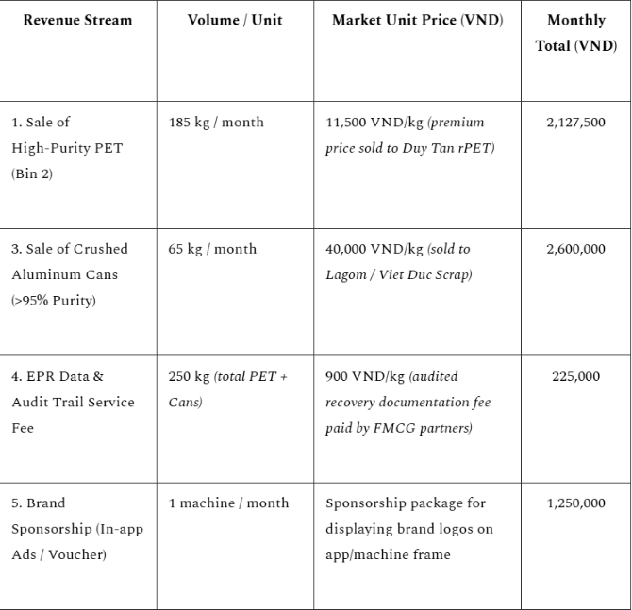
- After deducting technical maintenance operating expenses (1,270,000 VND/month) and allocated logistics OPEX (3,267,000 VND/month), the system yields a Gross Profit of 1,665,000 VND/month, translating to a healthy Gross Margin of 26.8%.
- Operational Efficiency: By pre-sorting and compacting materials before shipment, GreenGuard aims to reduce downstream handling and logistics inefficiencies. Because materials are compressed, drained, and pre-sorted on the spot, volume-to-weight ratio improves significantly, reducing logistics cost per tonne compared to loose, unsorted collection Real-time batch tracking also takes the guesswork out of downstream quality control and purchasing.
- Behavioral Change: The reward mechanism encourages users instead of punishing them, helping them participate in source separation and submit better-prepared material voluntarily.
- Data as Infrastructure: Every unit functions as a live data hub, tracking brand, volume, material type, and timestamps. At scale, the system could create a real-time dataset on post-consumer packaging collection.

3.4. Feasibility & Early Validation
Clear explanation on logic and references used to support your idea:

GreenGuard was developed around a practical problem observed in the recycling chain: recyclers are hungry for cleaner and more consistently sorted input material. While Vietnam produces over 8,000 tonnes of plastic waste daily, barely 26% gets properly recycled (MoNRE, 2021). A prime example is Duy Tan Recycling, one of the country's top Bottle-to-Bottle plant. Despite growing capacity over 150× in five years (331 to 50,376 tonnes, 2020–2025) and exporting food-grade rPET to 18 countries — with 57% of output going to international markets in a region that holds 40–45% of global rPET market share — Duy Tân's plant still runs well below its 100,000 tonne/year capacity due to a shortage of quality input material – roughly half of the PET collected is rejected for food-grade processing due to upstream feedstock being unsorted and contaminated.

Moreover, with the additional EU’s PPWR mandate which requires 30% recycled PET by 2030, the economic importance of reliable access to suitable recycled feedstock is further strengthened.

Vietnam's beverage can market is massive - 4.6 billion litres of beer consumed in 2024 alone, over 9 billion cans in annual production capacity, and a metal packaging market worth around USD 812 million. That volume creates a large, predictable aluminum stream that GreenGuard captures as a second material output alongside PET. On the buyer side, LME aluminum held at USD 2,500–2,800 per tonne throughout 2025 amid a global supply shortfall of 400,000–600,000 tonnes — making clean UBC a sought-after industrial input, not just scrap. Since recycling aluminum uses 95% less energy than primary production, buyers with decarbonization targets are increasingly treating it as a strategic material. GreenGuard's machines sort and compress cans separately at point of collection, consistently hitting the >95% purity threshold that commands premium pricing — a standard that mixed bins and informal collectors rarely meet. Identified buyers include LAGOM Vietnam and Viet Duc Scrap.

These market needs are directly aligned with GreenGuard's approach of performing quality control at the collection point.

Aside from the on-going and future demands, EPR policies are also forcing corporate actions. Under Decree 08/2022 (and Decree 110/2026), FMCG giants like Coca-Cola, Heineken, and Unilever must legally prove their recycling quotas with auditable trails — or pay approximately 435,000 VNĐ per tonne of plastic packaging placed on market into the National Environmental Fund with nothing to show for it. The scale of obligation is significant: PRO Vietnam, a coalition of 30+ leading FMCG companies, already managed 64,500 tonnes of packaging recycling in 2024 alone — and has committed to recycling 100% of its members' packaging by 2030. Meanwhile, Coca-Cola Vietnam consumed 154 million unit cases in 2024 and is actively piloting 100% rPET bottle lines, while Suntory PepsiCo launched fully recycled plastic bottles as early as 2022 — signaling that these companies are not just complying, but competing on circularity. This is where informal scrap sectors fail as they can't offer compliant receipts — something that our real-time tracking dashboard can easily provide.

So, how do we ensure a stable quantity and quality for these companies people may ask? Consumer compliance is the answer. We fully believe in incentives rather than awareness — relying on goodwill doesn't scale. By offering immediate, redeemable points for cash or vouchers on our app, we tap into the same consumer habit loop that drove Norway’s Infinitum system to a 97% recovery rate. Furthermore, a point scaling system mandates the purity where the better the bottles conditions, the higher the points rewarded. With this solution, we look forward to boosting user deposits to ensure a clean and stable waste source.

What has been tested / failed / learned from your prototype or basic evaluation test?

A. AI Classification (YOLOv8n) & Optical Inspection:
- We initially trained our classification model using over 500 outdoor, upright samples of PET bottles and aluminum cans of various colors.
- When deployed inside the enclosed RVM intake bin, the model failed drastically, with accuracy dropping below 55%. The model particularly struggled to detect small components like bottle caps and neck rings due to the horizontal placement and confined space. To resolve this, we introduced a supplementary U-Net Segmentation model dedicated solely to neck ring detection. While this successfully boosted cap, ring, and label accuracy to >85%, it created a critical hardware bottleneck. The dual-model architecture was too computationally intensive; it ran smoothly on a laptop but caused severe latency and overload when deployed to the resource-constrained embedded computer inside the RVM.
- We learned that optimizing the physical environment and dataset is far more effective for edge computing than stacking heavy AI models. We discarded the U-Net approach and installed diffused LED lighting inside the intake bay to standardize exposure and eliminate shadows. We then built a new custom dataset of 1,500+ images capturing materials lying horizontally inside the actual RVM chamber. We heavily targeted edge cases, specifically training the model on images where caps and neck rings were partially obscured by the mechanical compaction frame. By refining our data preprocessing with this highly contextual dataset, we achieved a final accuracy of >94.5% across all labeled objects on a single, lightweight YOLO model that runs smoothly on our embedded hardware.
B. Capacity & Compaction Dynamics
- Initially, our system was designed strictly for automated material classification. However, early field deployments revealed that optimizing bin capacity is equally critical. Without physical compaction at the source, the logistics cost of transporting low-density, loosely collected waste to downstream industrial recyclers (such as Duy Tan Recycling for PET, and Viet Duc Scrap or LAGOM Vietnam for aluminum) severely limits operational scalability.
- To quantify this bottleneck and evaluate our mechanical solution, we conducted a continuous one-week telemetry survey at a high-traffic HCMUT engineering campus canteen, recording an average daily intake of 400 PET bottles and 200 aluminum cans:
Table A: Capacity & Compaction Dynamics:
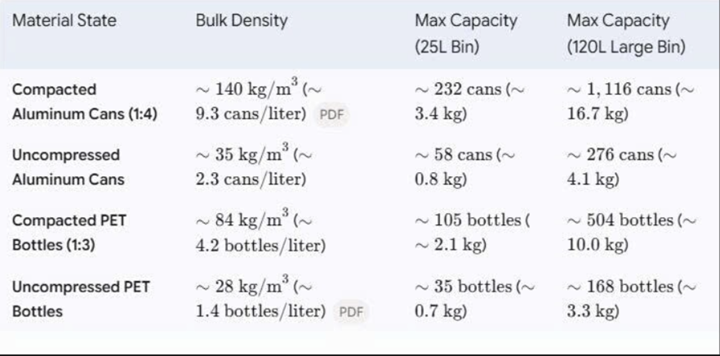
Table B: Estimated Fill-up Time at a High-Traffic Canteen:
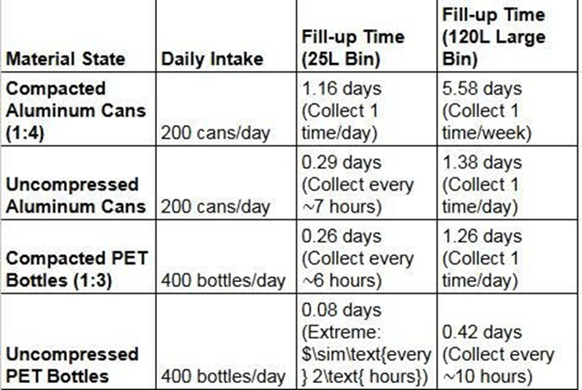
As demonstrated in the empirical data above, mechanical compaction drastically alters the operational viability of the system. For a standard dual-bin 120L setup, processing uncompressed materials is logistically paralyzing, requiring the maintenance team to execute approximately 22 collection trips per week (emptying PET every ~10 hours and aluminum daily).
By integrating the 1:3 (PET) and 1:4 (Aluminum) compaction mechanisms at the point of disposal, the system significantly extends the bin fill-up time. The total collection requirement drops to just ~7 trips per week (once a week for aluminum, and roughly every 1.26 days for PET). This achieves a nearly 70% reduction in logistical transport overhead, effectively transforming the RVM from a basic collection bin into a high-density material consolidation hub.
C. Mechanical Sorting & Compaction:
- We initially tested a pneumatic cylinder system to maximize the crushing force for handling both PET bottles and aluminum cans.
- The required air compressor was excessively bulky, costly to procure and maintain, and fundamentally unsuited for a compact, standalone RVM. We pivoted to an 800N electric linear actuator for a more compact footprint. However, because it operates on a lead screw mechanism, the trade-off for high force was a drastically slow stroke speed. To optimize the stroke length and reduce the time difference between crushing 500ml and 1500ml bottles, we shifted the design from vertical to horizontal compression. This introduced a critical structural failure: when crushing small items (< 250ml), the objects would slip to one side of the pressing chamber. This asymmetric load caused the pressing plate to bend and warp, resulting in incomplete compaction and threatening to damage the actuator shaft.
- We completely re-engineered the mechanical compaction block to handle off-center loads. We integrated two linear guide rails parallel to the actuator to distribute the lateral forces and ensure a strictly straight, stable translational stroke. Additionally, we upgraded the pressing plate to heavy-duty steel (over 6mm thick) to completely eliminate structural deflection. These mechanical reinforcements completely neutralized the bending issue, allowing the compact electric actuator to consistently and fully crush all acceptable bottle and can volumes without stalling
D. Edge Computing & Network Stability:
- Simulated network dropouts and high latency on our initial cloud-dependent 4G/LTE architecture to mimic real-world deployments (e.g., basements).
- Synchronous API calls blocked the main software thread during network lags (>2 seconds). This caused the system to miss UART serial interrupts from the microcontroller, leading to hardware desynchronization: the machine ingested items, but the UI froze, the sorting flap failed, and users lost their rewards.
- Fixed: We decoupled the hardware control loop from the network by adopting an asynchronous edge-computing architecture with a local SQLite database, reducing physical processing latency to <0.2s. For offline periods, the RVM generates a QR code containing an encrypted JWT payload. Users scan it to cache the reward locally. Once reconnected, a background thread automatically syncs data to the cloud and validates hashes to prevent duplicate claims, guaranteeing 100% mechanical uptime and zero data loss.

Define your target market for the product/service, using relevant data and research:
GreenGuard targets a B2B market built around two complementary revenue streams: standardized recyclable materials and traceable collection data. Consumers are the users who supply the material, while businesses are the primary potential customers and partners that derive commercial value from GreenGuard's outputs.
Our first target market consists of recycling companies, material processors, collection companies, and scrap consolidators that purchase recyclable PET and aluminum.
- For high-purity PET, potential buyers include Duy Tan Recycling and similar downstream recyclers seeking consistent and clean PET feedstock.
- For sub-standard PET, GreenGuard does not mix it with the high-purity stream. Instead, collection workers within our logistics network handle preprocessing it into high-purity PET. Once it meets the required standard through manual preprocessing, it is transported alongside the high-purity PET stream.
- For aluminum cans, our potential downstream buyers include collection and processing partners such as LAGOM Vietnam, a collection company associated with Anglo Asia, as well as industrial scrap processors such as Viet Duc Scrap.
Our second target market consists primarily of large FMCG and beverage companies with extended producer responsibility (EPR) obligations or corporate recycling targets.
For these companies, GreenGuard provides a different type of value: a traceable collection channel supported by real-time data. Each transaction can generate information such as material type, quality status, collection volume, timestamp, and location. This data can help companies monitor their collection activities and build more transparent records of their recycling efforts.
GreenGuard can work with these companies through two potential models:
- Data/service model: companies pay for access to collection, monitoring, and reporting services.
- Partnership model: companies cooperate with GreenGuard by sponsoring or providing vouchers and rewards for users, while gaining visibility through the collection platform and associated recycling data.
The partnership model also connects the B2B and consumer sides of the system: companies gain a structured recycling channel and user engagement, while consumers receive tangible rewards for returning recyclable materials.
The opportunity is strengthened by growing demand for recycled material. For example, EU Regulation 2025/40 establishes a 30% minimum recycled-content requirement for single-use plastic beverage bottles from 2030, increasing the importance of reliable post-consumer recycled feedstock for companies supplying the relevant market.
At the current stage, these organizations should be described as potential customers or partners rather than confirmed customers, as GreenGuard has not yet secured formal off-take contracts. Our next commercial-validation step is therefore to convert the identified downstream buyers and corporate partners into pilot agreements, purchase commitments, or sponsored collection partnerships.
Regarding Core Unit Financials, the model demonstrates strong profitability potential. Each RVM unit has an initial capital expenditure (CAPEX) of 19,000,000 VND, which can be optimized down to 16,000,000 VND when scaled to a production batch of 15 machines. Regarding the Discounted Payback Period (DPP), our calculation is based on a Discount Rate (WACC) of 1.0% per month (approx. 12% annually) to account for capital cost and inflation, and an Estimated Asset Lifespan of 3 years (36 months), with a CAPEX of 19,000,000 VND:
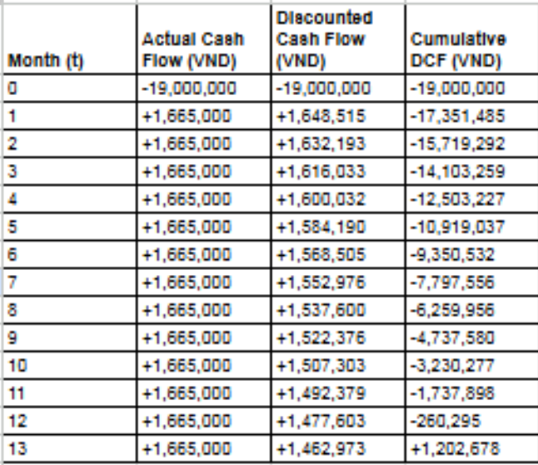
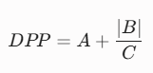, with:A = 12 (Last period with a negative cumulative DCF).
B = -260,295 (Cumulative DCF at the end of period A).
C = 1,462,973 (DCF during the period following A).
The system has a Discounted Payback Period (DPP) of 12.18 months, indicating the machine will break even in roughly 1 year (12 months and 5 days). With a conservative estimated asset lifespan of 36 months, the project retains approximately 66% of its operational life for pure profit generation.
Each unit yields a positive Net Present Value (NPV) of 31,128,996 VND and an annualized Internal Rate of Return (IRR) of 158%. This outstanding IRR confirms that GreenGuard's cost structure can comfortably absorb unexpected operational shocks, easily clearing the standard 30-40% venture capital hurdle rates for hardware depreciation risks.

3.5. Value Chain Integration
Describe the broader ecosystem of your solution (realistic stakeholders and how they interact):
• Who supplies your input material?
• Who processes it?
• Who buys or uses the output?
• Which step is the most fragile or dependent?

GreenGuard’s ecosystem is a closed-loop service rather than a standalone machine sale.

Stakeholder | Role | What they provide / receive | Value created
Users / citizens | Input suppliers and participants | PET bottles / aluminum cans; receive points, vouchers, or other rewards | Incentivizes source separation and gives immediate value for recyclable material
GreenGuard | Collection, sorting, quality control, data, and service operator | Operates RVMs, performs classification/inspection/compaction/sorting, manages app + dashboard | Converts mixed postconsumer containers into more standardized saleable streams.
Recycling companies | Primary downstream buyers / processors | Receive higher-quality PET feedstock | Reduce upstream contamination and manual pre-sorting burden.
Low level buyer / processing partners | Secondary downstream channel for non-compliant PET | Receive sub-standard material for further sorting/reassessment | Keeps non-compliant material in the recycling chain instead of mixing it with high-purity output.
Collection centers / industrial scrap consolidators | Downstream channel for aluminum and relevant scrap streams | Receive compressed aluminum and other sorted scrap | Provides a more consistent, compact material stream.
FMCG / brand partners | Potential commercial and data partners | Can provide reward sponsorship / EPR-aligned demand and use traceable collection data | Links consumer engagement, recycling activity, and measurable collection data.

3.6. Development Strategy (From Idea to Action)
Outline your plan to bring the project into reality, and how you will measure outcomes at each phase.
Phase | Key activities / milestones | How outcomes will be measured
3 months | • Refine the RVM based on field-testing results, with particular focus on the intake area, user-assisted label/ring removal, AI classification, PET quality inspection, and sorting reliability.  • Improve the point-scaling system so rewards better reflect material quality and encourage correct user preparation.  • Continue controlled campus deployments to collect real-world operating data.  • Establish a standardized grading specification for high-purity PET, sub-standard PET, and aluminum outputs.  • Begin technical discussions with potential downstream buyers to confirm their material-quality requirements. | • Classification and sorting accuracy of the prototype.  • Percentage of deposits correctly separated into the three output streams.  • Rate of inputs meeting the required PET preparation standard.  • Number and volume of real deposits processed.  • User compliance with the preparation procedure.  • Feedback from potential downstream buyers on output quality and specifications.
6 months | • Deploy a small number of RVMs in selected high-footfall locations such as campuses, supermarkets, or partner sites.  • Operate the complete collection → reward → data → downstream-material cycle under real operating conditions.  • Test different reward structures and voucher partnerships to improve user participation and material quality.  • Secure pilot cooperation, letters of intent, or trial purchase arrangements with potential PET and aluminum buyers.  • Develop the commercial packages for the two revenue streams: material sales and data/collection services.  • Quantify the actual cost of operating, collecting, transporting, and processing each material stream. | • Deposits per machine per day/week: Target surpassing the daily operational break-even volume of 198 items/day (approx. 135 PET bottles and 63 aluminum cans).  . • Percentage of PET meeting the high-purity specification: 95%  • Material volume and value recovered per machine: Validate the estimated average recovered value of ~420 VND per item (PET, Aluminum, and EPR Data) against the estimated daily machine operating cost of ~83,000 VND  • Cost per kilogram collected and processed: Monitor the logistics burn rate to ensure the total cost approaches the target operational baseline of ~24,020 VND per kg  • Number of active downstream and corporate partners: Secure active engagement with identified material off-takers (e.g., Duy Tan rPET, Lagom, Viet Duc Scrap) and FMCG brands for EPR data services.  • Revenue or committed commercial value generated from pilot operations: Track operations against the projected unit economics to aim for a 6,202,500 VND total monthly revenue per machine.
12 months | • Expand the RVM network into multiple high-footfall collection locations based on pilot performance.  • Standardize machine deployment, maintenance, collection logistics, and output-quality control so multiple units can be operated consistently.  • Formalize recurring sales channels for high-purity PET, sub-standard PET, and aluminum.  • Establish long-term partnerships with FMCG/brand companies for collection programs, reward sponsorship, and traceable recycling data.  • Improve the backend dashboard into a scalable reporting platform for monitoring material flows, user activity, machine status, and collection performance.  • Use accumulated operating data to determine the most profitable locations, materials, reward structures, and downstream channels. | Quantified metrics for setting achievable targets:  Number of active RVM locations: Scale up to a localized network of 15 RVM units confined within 1 HCMC Ward to establish a baseline for optimized logistics routing and minimize fuel consumption.  Total PET and aluminum volume collected: Reach a network-wide collection target of approximately 3,825 kg/month, equivalent to ~18 m³ of compressed volume, to drive the core logistics unit economics.  Collection cost and gross margin per material stream: Stabilize the total monthly logistics OPEX for the 15-unit network at 49,000,000 VND (approximately 3,267,000 VND per machine) while achieving the projected Gross Margin of 26.8% (Gross Profit of 1,665,000 VND/unit).  Recurring material-sales and data/service revenue: Maintain a steady revenue stream aiming at the target of 6,202,500 VND per unit across the expanded network.  Metrics requiring practical implementation for data collection and further development:  Output purity and rejection rate.  Machine uptime and maintenance frequency.  Number of recurring B2B customers/partners.  Number of users and repeat-deposit rate.  Amount of material successfully transferred into downstream recycling channels.

3.7. Human Resources
List everyone involved in the project and their role(s) and responsibilities:
Full name | Role in the team | Main responsibilities
Tuong Nakimoto0nichan
Huỳnh Hoa Minh
Nguyễn Trọng Vinh
Thái Trọng Đăng
Vi Tuấn Khoa

EVALUATION CRITERIA — GRAND FINAL (for reference)
1. Technical Concept & Solution Development
2. Circular Impact & Value Creation
3. Feasibility & Early Validation
4. Value Chain Integration
5. Development Strategy (From Idea to Action)
6. Human Resources
Note: The criteria above remain unchanged from Round 2. In addition, judges will place particular weight on (1) the progress your team has made since Round 2, and (2) how well you have addressed the feedback received from judges after Round 2.

Please submit this form together with your presentation slides by the deadline announced by the organizing committee.

